# Westfalia Amundsen 600D (Registered July 2016)

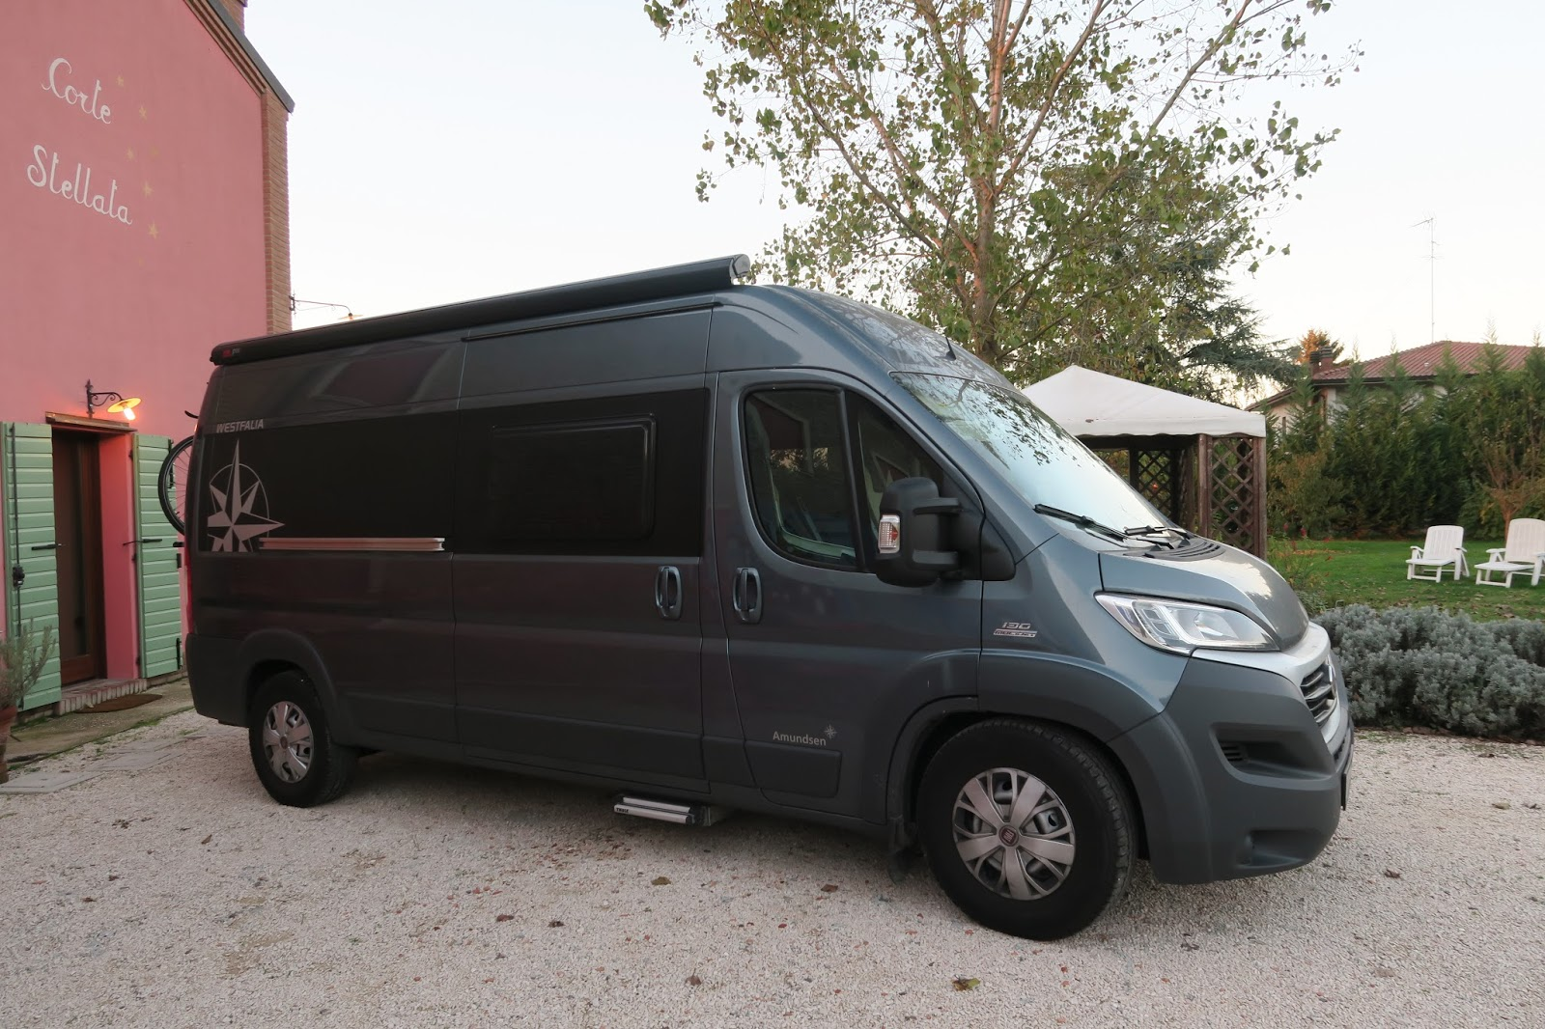

## Base Vehicle

#### Engine and Gearbox

* Fiat Ducato L4H2 (5,998mm)
* 2.3 l 130 Multijet 96 kW / 130 HP
* Left hand drive
* Front-wheel drive Panel van
* Euro 5 + particles filter
* Manual gearbox 5-gears

#### Comfort, design and safety

* Centrally-controlled locking system with remote control
* Power-operated front windows
* Covers for sitting base and sitting box
* Captain chair seats with double arm rests and integrated head-rest, height adjustment (driver seat), swivel brackets, same fabric as the seat bench („Grizzly” fabric)
* Cup-holder
* Instrument cluster with chromed gauges frames
* Tablet holder
* Anti-lock braking system (ABS with electronic brake force distribution), mechanical brake assistant (MBA)
* Electronic immobilizer
* 12 V / 95 Ah Battery
* Driver airbag •
* Daytime running light
* ESP Traction +

## Standard Equipment

#### Living and Sleeping

* Floor with abrasion-proof plastic cover
* Comfortable two-seater bench with built-in safety belts and Isofix-attachment point,
* fabric same as driver and co-driver seat, compartments under the seat bench
* Comfortable rear bed 1,400 x 1,970 mm, removable slatted frame incl. helping step
* Table for living room, stored in the storage compartment over the drivers cabin
* Power-operated entry step
* 2-burner gas stove with piezo ignition and glass cover
* High-quality stainless steel sink with pivotable fitting
* Soft-close system drawers
* 95 l compressor fridge with freezing compartment
* Extensible kitchen working space
* Wet cell with shower tub and 2 basin wastes
* Rotating Thetford C 250 S cassette toilet
* Washbasin with pull-out fitting with suction feet
* Mirror cabinet in wet cell
* Towel holder, toilet roll holder
* Swing door with inward- and outward-opening
* Easy access and exit through the back door with optimised handle position even in position when bed is made

#### Storage and transport

* Floor cupboards in the rear bed area
* Rear storage room under the rear bed, can be enlarged variably
* High-quality inside covers with integrated storage compartments
* Multi-functional cabinet behind seat bench
* Roof storage compartment with LED lights rightside, above the kitchen
* Roof storage compartments LH and RH above the bed, RH with LED lights
* Roof storage compartment left side above the seat bench, incl. LED lights
* Clothes rail behind the wet cell

#### Heating, airing and design

* Window with privacy glassing, with built-in blind system and flyscreen, 2 windows in the rear doors, 1 side window front left-hand side next to seat bench and 1 in the sliding door
* 3 Remis Top lift and tilt rooflights (400 x 400 mm) (sleeping area, wet cell, living area) with built-in blinds and flyscreens
* Truma-Combi 4 KW hot air heating with built-in water heater under seat bench
* LED rail above cooker / kitchen, sliding door area
* LED light in wet cell

#### Gas, Water, Electric systems and safety

* Westfalia central electronic system to control and monitor all on-board functions
* On-board grid 12 / 230 V with battery charger, 1 powerful 95 Ah AGM battery
* Gas installation with safety box for two 11 kg gas bottles
* Fresh water tank inside, approx. 90 Ltr
* Waste water tank under the floor approx. 100 Ltr

## Westfalia Installed Extras

* Westfalia Chassis Plus Package
  + Black decorative decals outside
  + Fuel tank 120 Ltr
  + Manually operated air conditioning for driver cabin with designer covers and pollen filters
  + Co-driver airbag
  + Electrically adjustable mirrors
  + Height adjustable co-driver seat
  + Radio pre-installation in combination with loud speakers (in drivers cab)
  + LED electric package: LED light lines in the roof storage compartment and additional 12 V / 230 V sockets in seat bench area, rain and LED light line above sliding door (dimmer and remote control included)
  + Cruise Control 1 NHR 279,00
  + Remis folding blind set for front and side windows (in drivers cab)
  + Flyscreen door
* Westfalia Polar Package
  + Rear and front mud flaps
  + Front heated seats
  + Winter Package
    - 6 kW gas heating with 230 V heating cartridge for stationary operation with CP Plus control
    - Heated waste water tank
    - Insulated rear door and sliding door, Insulation mat for windscreen
  + Additional powerful 95 Ah AGM battery
  + Insulating windscreen
* Handles in body colour
* Iron Grey Metallic Paint
* Permissible Total weight upgrade to 3,500kg
* Maxi Chassis (Improve suspension and 215 / 75 R 16 CP M&S Tyres)
* Outside shower hot / cold incl. shower head and suction foot
* Preparation for solar modul and TV
* Spare wheel with fixation
* Safety locking system (Dead Lock)
* Storage partition
* Awning 3.75 m in anthracite

## After market Extras

* SOG
* Thule Bike Rack G2 Elite Van
* 2 x 120w Solar Panels (Bosch Cells) with 20A MPPT Charger (Tracer221BN) and digital display
* Gaslow refillable LPG Twin Cylinder kit (2 x 11kg R67 bottles)
* Truma Monocontrol CS (Crash Sensor) Regulator and High-Pressure hoses with HRP (Hose Rupture Prevention)
* Two rear view/reversing cameras (One under bumper and one in central break light) with 72 TFT LCD Monitor on dashboard
* Alfa Wifi Camp-pro range extender
* Seagull IV X-2KB 0.1 Micron Water Filter (Fitted inline after the fresh water tank)
* Upgraded fresh water pump
* Additional USB ports
* Lepy Digital Stereo amplifier with 3.5mm Jack